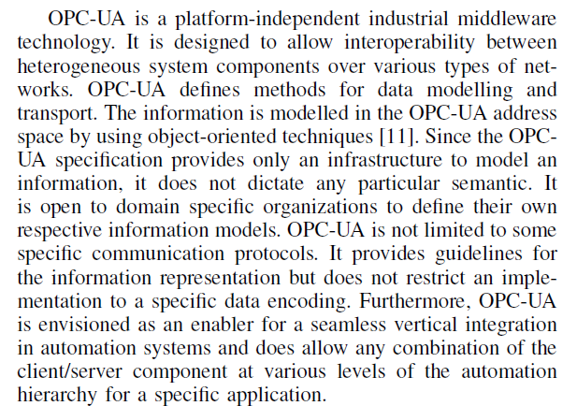

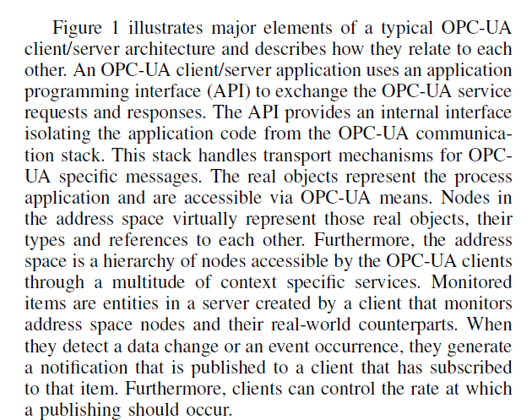

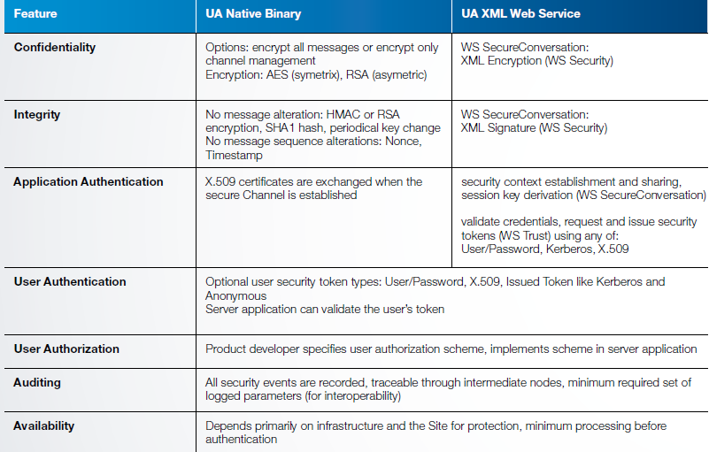

Mobility and Security

Mobility: 24/7 monitored home security, remote access, effortless control and more requirement what’s happening when you are away, let pet sitter or repairmen in remotely, manage your thermostat, lights and so on, detect a water leak to avoid major damage. With the help of digital door lock, different sensors and powerful computer

Also mobility in industry and business world is a critical assert, which can not only increase efficiency and productivity but also drive new revenue generation and competitive advantage. With mobility people, processes and assets can be always connected and be optimized on the go.

Proof:

<http://www.eiumedia.com/index.php/latest-press-releases/item/1205-mobility-benefits-put-at-risk-by-companies-inattention-to-work-life-balance-and-security-issues-says-economist-intelligence-unit>

But there exit some tough issues when we are facing aforementioned mobility.

1 interconnected and interoperability -> using newly released standard OPC UA

2 security -> smart card

Smart card security and insecurity

Smart card = a small microchip installed with all your details.

Smart card and its technology have evolved the way the world functions.

<http://www.brighthub.com/computing/smb-security/articles/67274.aspx>

<http://www.ibuzzle.com/articles/advantages-of-smart-card-technology.html>

Result: combination

Adapting opc ua communication stack on smart card.

Schwerpunkt.

Program opc ua dummy client server application for the purpose of demo

Develop java applet on smart card that realize opc ua communication stack

Build application API that connects 1 and 2